+
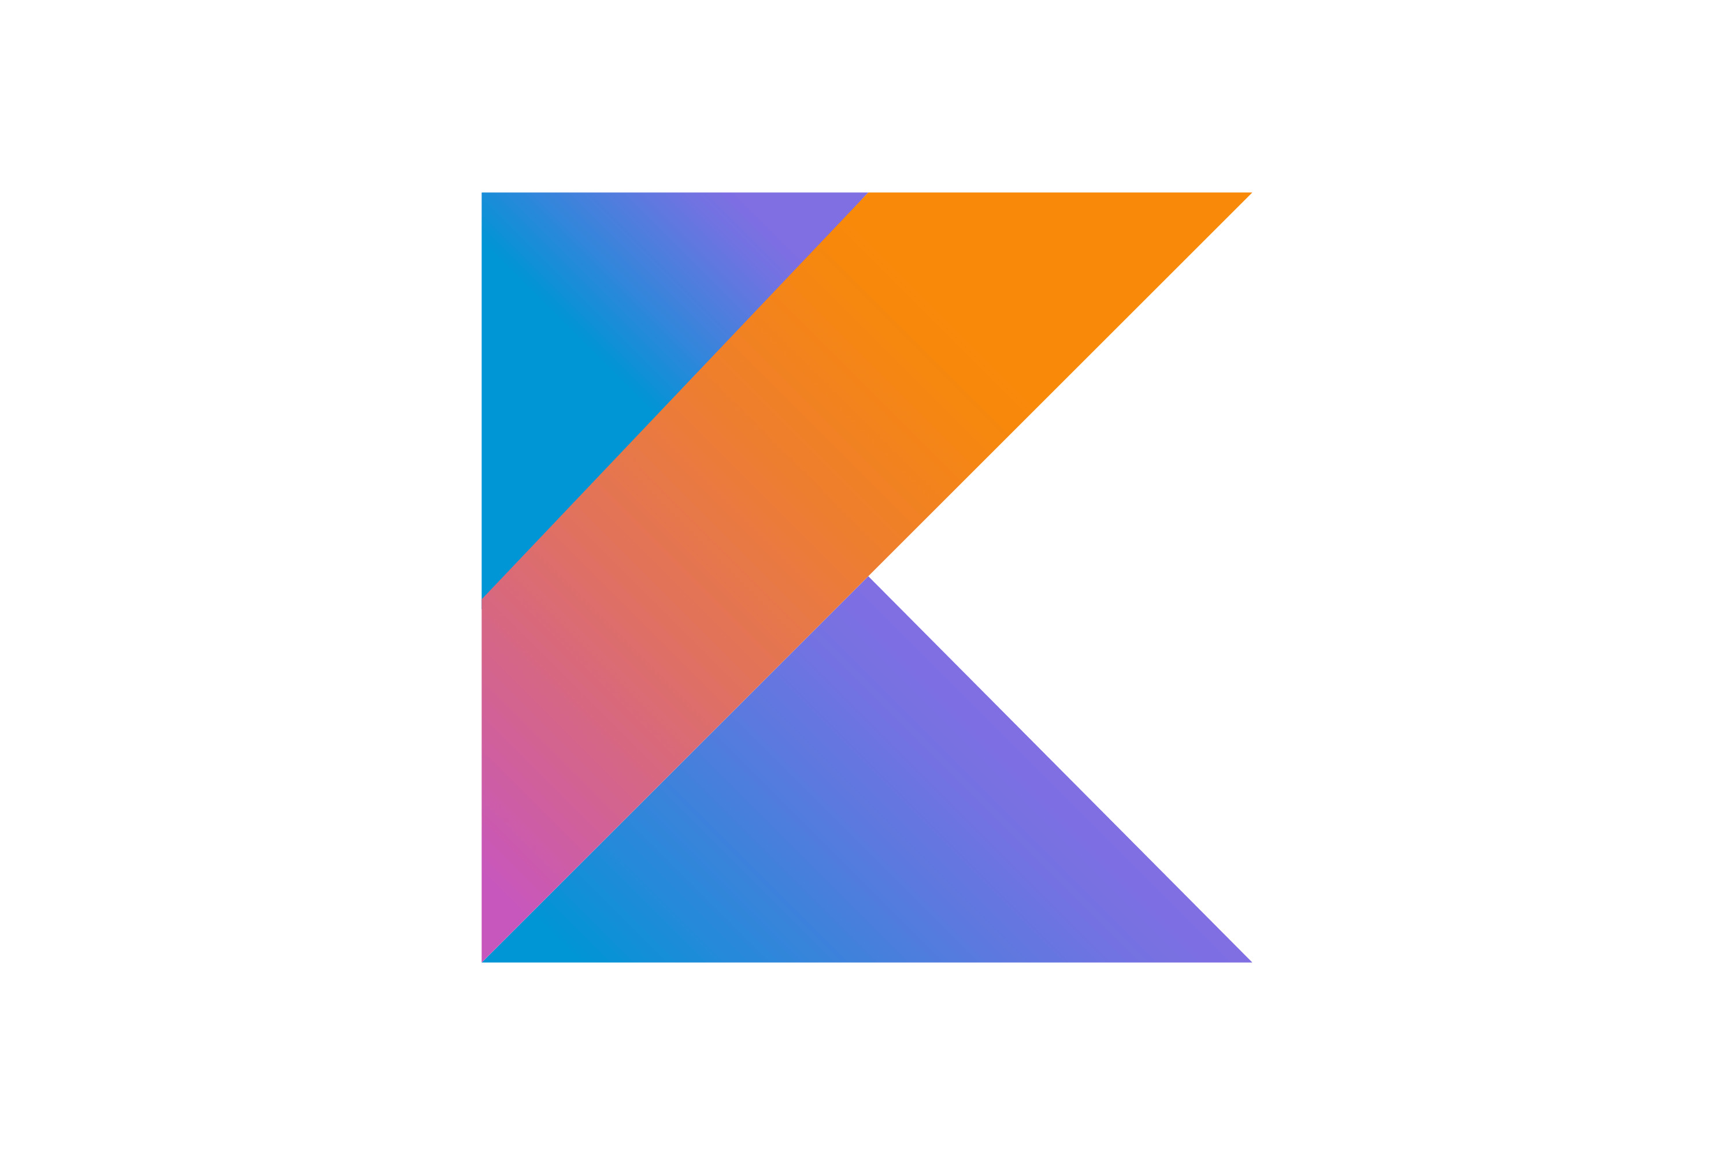  kotlin assignment  ICT ELECTIVES 3 ICE362S | Name: Thabiso  Surname: Matsaba  Student Number: 220296006  Lecturer: Arinze Anikwe  Due Date: 16 March 2022  ELECTIVE: KOTLIN

KOTLIN PROGRAMMING LANGUAGE

Prepared for
Mr Arinze Anikwe
Cape Peninsula University of Technology

Prepared by
Thabiso Matsaba

March 14, 2022

TABLE OF CONTENTS
Page

TABLE OF CONTENTS……............................................................................ ii
SECTION 1
Introduction....................................................................................................... 1
Kotlin belonging programming paradigms......................................................... 1
SECTION 2
Kotlin comparison on advantages, strengths, pitfalls with other programming languages in similar programming paradigms..................................................... 2
SECTION 3
How instructions written in Kotlin is executed by the computer.……………........................................................................................... 3
SECTION 4
The best use case(s) Kotlin.................................................................................. 4
SECTION 5
Bibliography……………………………………………………………………………. 5

Kotlin Programming Languange
Section 1
Introduction
In this research paper, I will be writing about the Kotlin programming language. I will mainly focus on the belonging programming paradigms, with explanations. Secondly Kotlins comparison on advantages, strengths, pitfalls with other programming languages in similar programming paradigms. Thirdly on how instructions written in Kotlin is executed by the computer. And finally on the best use cases of Kotlin and why I think Kotlin is either worth learning and/or using.
Kotlin is a relatively new Java-compatible language from prolific tool developers, JetBrains. It has been publicly available in beta form since 2012, and version 1.0 was released in 2016. Its powerful features and community support has convinced Google to make it an officially supported development language for Android. Kotlin supports three major programming paradigms. Imperative programming paradigm, Functional programming paradigm, and Object-Oriented programming paradigm.
Imperative programming as the name suggests is a type of programming paradigm that describes how the program executes. Developers are more concerned with how to get an answer step by step. It comprises the sequence of command imperatives. In this, the order of execution is very important and uses both mutable and immutable data. The imperative paradigm is the oldest computer programming paradigm. This paradigm presents as a central characteristic the definition of sequences of instructions representing modifications in the states of a computer system. Thus, we can see programs following the imperative paradigm as guides that describe how to accomplish some tasks.
The functional programming paradigm is a restriction on how we write programs, but not on what programs we can express. First-class functions are elementary functions for the functional paradigm. They can be assigned to variables, passed as arguments to other functions, and returned as other functions result. Pure functions follow the properties of transparency and lack of side effects. Transparency signifies that a function always returns the same result given the same input.
Lack of side effects means that a function doesn’t cause any state mutation in the program, for example, printing some information or sending data through the network. High order functions receive other functions as arguments or return a function as a result (or even both). An example is the map function, which executes a provided function to each element of a given iterable, thus returning a new iterable.
The object-oriented paradigm aims to represent the real world by modelling it similarly to our brains. Kotlin is an object-oriented programming language just like Java. This paradigm leads new meanings and properties to concepts from modular programming,
Classes are representations of things in the real world. Classes have a name and typically have several attributes and methods. Furthermore, different from modules that are imported only once in the same code context, we can instantiate classes multiple times as objects
Attributes are information stored in the context of a class. Thus, attributes represent the states of a class object. Attributes have some similarities with variables of modules. However, objects have name spaces. So, two objects of the same class can have different values for the same attribute
Methods or Functions in summary, is a procedure associated with a class. Methods or Functions are called on the context of a class object. Thus, methods or functions can produce internal changes, such as modifying an attribute value, and other side-effects, such as communicating over the network.
Kotlin has many advantages over Java, you can convert a Java file into a Kotlin file with just a script. Kotlin has no runtime overhead. Sometimes, adding features to a language means it has more overhead, which lowers its performance. Kotlin has a large community so If you ever get stuck, you can easily find other developers to help you on coding forums and social networks.
Kotlin streamlines asynchronous programming. Making network and database calls asynchronously in Java is clumsy and painful. Kotlin has coroutines that make asynchronous programming simple and efficient.
Kotlin handles nulls. A null in Java can crash a program if you haven't prepared for it. In Kotlin, you can add a simple operator to variables that may be null to prevent these crashes.
When comparing Kotlin with Java, Kotlin has an average code length around 20% shorter than Java, the efficiency of Kotlin is highlighted as a particularly valuable advantage. Not only can work be done more efficiently but the quality of the code is also improved because of it being more concise.
Kotlin’s versatility is another big plus. Due to its high degree of interoperability with Java, Java code can also be executed in Kotlin and vice versa. In addition, Kotlin’s many extensibility features mean that developers can add additional functionality to existing components without changing the main body of the code. This is advantageous because Kotlin’s library is quite small and does not use up memory as it consists of targeted extensions to the standard library.
Accordingly, there is no runtime overhead with Kotlin. When it comes to strictly technological advantages, Kotlin offers first-class support for functional programming, even though it is mainly object-oriented, making the most out of both paradigms and opening new programming possibilities.
Support for multiplatform programming is one of Kotlin’s key benefits. It reduces time spent writing and maintaining the same code for different platforms while retaining the flexibility and benefits of native programming.
One big issue with Kotlin is how a variable can be introduced at any given time in code. Kotlin allows a developer to declare variable(s) at any time within the code execution path and as well not have to declare the type. This makes it very hard for another developer in reading the code or even debugging the code. Allowing Kotlin to assign types to a variable based on a value being assigned to it leads to confusion when reading the code, makes debugging code harder as you may have to read hundreds of lines of code to understand the type that has been assigned to a variable.
The Java Virtual Machine(JVM) is used by computers to run Java bytecode. Kotlin also uses the JVM to compile high-level source code to lower-level machine byte code. Kotlin also compiles on Android’s run-time environment called ART23. When compiling in JavaScript, Kotlin transpiles to ES5.1 and generates code which is compatible with module systems including AMD and CommonJS. When targeting native, Kotlin will produce platform-specific code (via LLVM).
The best use currently for Kotin is Android Mobile and Application Development. Kotlin is relevant today because it’s open-source and offers extensive features. It develops as a solution to the problems that Android developers have faced for a while. It solves the queries that surfaced in Java, giving developers flexibility, safety, clarity, and tooling support.
A lot of back-end web development is done in Java, using frameworks like Spring. But Kotlin made inroads into server-side web development since it was so much easier for developers to work with. The modern features of the language make it possible for Web Developers to build applications that can scale quickly on commodity hardware. Since Kotlin is interoperable with Java, you can slowly migrate an application to use Kotlin one file at a time while the rest of the application still uses Java.
Kotlin also works with Spring and other frameworks, so switching to Kotlin doesn't mean you have to change everything you're used to. Google, Amazon, and many other companies have already replaced Java with Kotlin in some of their server-side code.
Data Scientists have always used Java to crunch numbers, detect trends, and make predictions, so it only makes sense that Kotlin would find a home in data science as well. Data Scientists can use all the standard Java libraries that they used for Java projects but write their own code in Kotlin. Jupyter and Zeppelin, two tools used daily by many Data Scientists for data visualization and exploratory research, also support Kotlin.
I believe Kotlin is worth learning now more than ever, because it is easy to learn and is interoperable with Java so you don’t have to immediately stop using Java or swap out all the code, you can use both. Kotlin is the leading Android development language, and Kotlin developers are in high demand. I believe that’s a good reason to learn and use this programming language.

BIBLIOGRAPHY
Difference Between Imperative and Declarative Programming [online] Geeks for Geeks
https://www.geeksforgeeks.org/difference-between-imperative-and-declarative-programming/
[Accessed 10 March 2022]
Imperative and Declarative Programming Paradigms [online] Baeldung
https://www.baeldung.com/cs/imperative-vs-declarative-programming
[Accessed 11 March 2022]
Kotlin vs Java: strengths, weaknesses and when to use which [online] K & C
https://kruschecompany.com/kotlin-vs-java/
[Accessed 12 March 2022]
Understanding OOP Concepts With Kotlin [Online] Dev
https://dev.to/kolanse/understanding-oop-concepts-with-kotlin-2kd8
[Accessed 13 March 2022]
What is Kotlin used for? [Online ] Code Academy
https://www.codecademy.com/resources/blog/what-is-kotlin-used-for/
[Accessed 14 March 2022]

